Блокнот Шеннона

alp = "АБВГДЕЖЗИЙКЛМНОПРСТУФХЦЧШЩЪЫЬЭЮЯ".lower()
for_big_text = "АБВГДЕёЖЗИЙКЛМНОПРСТУФХЦЧШЩЪЫЬЭЮЯ".lower() + "АБВГДЕЁЖЗИЙКЛМНОПРСТУФХЦЧШЩЪЫЬЭЮЯ" + " !\"#$%-'()*+,—–./:;<=>?@[\]^_`{|}"
# print(alp.index("A"))
def gamma(mes, a, c, T0, mode):
if mode == 1:
alp_arr = []
for i in mes.lower():

alp_arr.append(alp.index(i))
arr = [T0]
for i in range(len(mes)):
t = (a*arr[-1]+c) % 32
arr.append(t)
arr.pop(0)

return arr, alp_arr
else:
alp_arr = []
for i in mes:
alp_arr.append(for_big_text.index(i)+1)
arr = [T0]
for i in range(len(mes)):
t = (a*arr[-1]+c) % 98
arr.append(t)
arr.pop(0)
return arr, alp_arr

def encrypt(message, one_time_pad, mode):
if mode == 1:
arr = []
for i in range(len(message)):
arr.append((message[i]+one_time_pad[i]) % 32)
print(arr)
return "".join([alp[i] for i in arr])
else:
arr = []
for i in range(len(message)):
arr.append((message[i]+one_time_pad[i]) % 98)
print(arr)
return "".join([for_big_text[i] for i in arr])
def decrypt(ciphertext, one_time_pad, mode):
if mode == 1:
arr = []
for i in range(len(ciphertext)):
shift = (alp.index(ciphertext[i])-one_time_pad[i]+1) % 32
arr.append(shift)
return "".join([alp[i-1] for i in arr])
else:
arr = []
for i in range(len(ciphertext)):
shift = (for_big_text.index(ciphertext[i])-one_time_pad[i]) % 98
arr.append(shift)
return "".join([for_big_text[i-1] for i in arr])

from math import gcd

mode = int(input("Выберите задание (1 - карточка, 2 - текст): "))
a = int(input("a = "))
if mode == 1:
check = 32
else:
check = 99

if a%2 != 0 and a%4 == 1 and a > 1:
x = 32 if mode == 1 else 98
c = int(input("c = "))
if gcd(c, x) == 1:
T0 = int(input("T0 = "))
if 0<T0<check:
message = str(input("Введите текст: "))
one_time_pad, msg = gamma(message, a, c, T0 , mode)
ciphertext = encrypt(msg, one_time_pad, mode)
print("Зашифрованный текст:", ciphertext)

decrypted_message = decrypt(ciphertext, one_time_pad, mode)
print("Дешифрованный текст:", decrypted_message)
else:
print("c не взаимно прост с модулем m")
else:
print("неверные значения. a должно быть нечётным, больше 1 и меньше 32; T0 должно быть больше 1 и меньше мощности алфавита")

Тест работы:
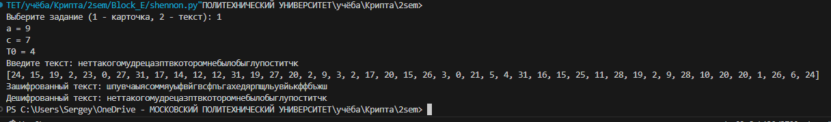

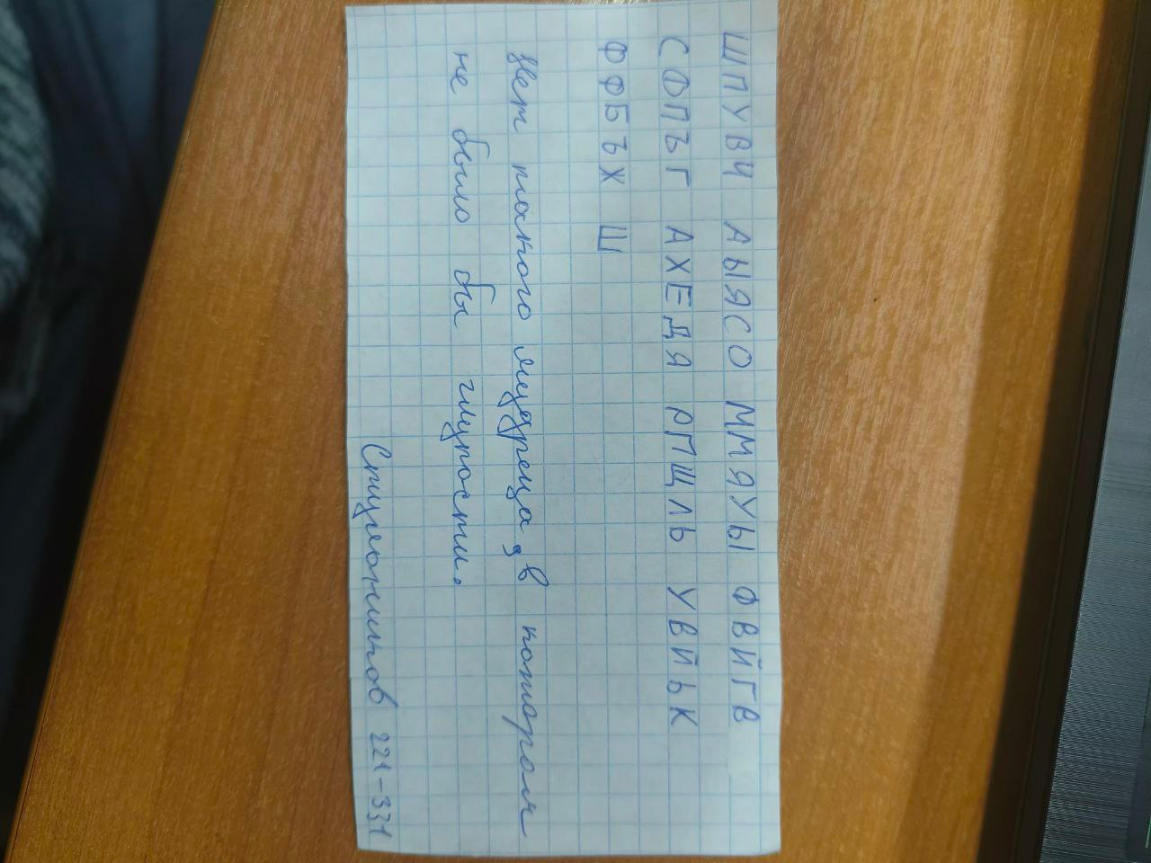
Тест на тексте > 1000 символов:
